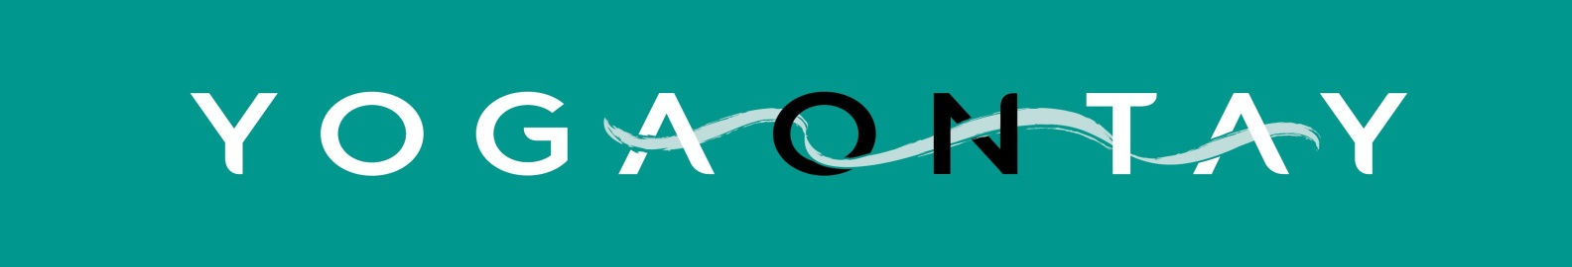

Privacy notice for Yoga on Tay (May 2018)

Yoga on Tay takes your privacy seriously. We are a “controller” of the personal information that you provide to us and this privacy notice sets out how, why and for how long we will use your personal data, as well as who (if anybody) it is shared with. It also explains your legal rights as a ‘data subject’ and how to exercise them.

What we need from you

When you register as class participant with Yoga on Tay, or are asked to update you’re your personal details or health declaration we may ask you for some or all of the following personal information:

- Contact details – eg. name, address, email address and phone number.
- Yoga experience – information about any previous yoga experience prior to (or as well as) coming to Yoga on Tay classes
- Details of an emergency contact
- Health declaration and details of any relevant health conditions and/or medication

If you do not provide us with all of the personal information that we need this may affect our ability to offer you our yoga classes.

Why we need your personal information – contractual purposes

We need to collect this personal information so that we can manage your relationship with us. We may use your personal information to:

- Provide you with core services (yoga instruction)
- Enable us to respond to any health (and safety) issue that may arise during yoga classes
- Provide you with information should classes be cancelled at short notice

Why we need your personal information – legitimate purposes

We also process your personal information in pursuit of our legitimate interests to:

- Provide you with news and updates about Yoga on Tay, workshops, events via email newsletter - but ONLY if you have given us permission (by subscribing to the newsletter online, or by telling us on the registration form that you would like to receive information on classes, retreats etc by email)
- Respond to and investigate your questions, comments, support needs, complaints or concerns

Who we share your personal information with

We do not routinely share your personal information with any person or organisation.
We may, in exceptional circumstances, share personal information with professional and legal advisors for the purpose of obtaining advice.

Third party supplier with access to members’ personal data

Yoga on Tay may use a third party suppliers to provide services (for example the online booking system; online newsletter provider) . These suppliers may process personal data on our behalf as “processors” and are subject to contractual conditions to only process that personal information under our instructions and protect it.

In the event that we share personal information with external third parties, we only share such information strictly required for the specific purposes and take reasonable steps to ensure recipients shall only process the disclosed personal information in accordance with those purposes.

- Mailchimp (newsletter) - we enter email addresses and names onto the Yoga on Tay Mailchimp account ONLY of those who have given their consent to receiving such emails
- Glofox booking system - you (or we) provide name, email, phone and (optional) payment details on Glofox to allow you to book classes in advance online

How we protect your personal information

Your personal information is accessed by our teachers and administrative support only for the purposes set out above.
It is stored by Yoga on Tay in paper form (on the registration form you completed) and is securely stored in files accessible to the teachers at the Studio.
The Mailchimp and Glofox information account s are held on a remote server and the accounts are password protected.

How long we keep your personal information

We only keep your personal information for as long as necessary to provide you with yoga classes and allow you to book classes. If you have not attended or booked classes for over two years, we will securely delete your information. Personal details held for the (opt-in) newsletter will be held until such time as you unsubscribe yourself or ask us to remove you.

You have a right to:

- Change your communication preferences or restrict the processing of your personal data for specific purposes.
- Request that we correct your personal data if you believe it is inaccurate or incomplete.
- Request that we delete your personal information.
- Access the personal data that we hold about you through a “subject access request”.

You can contact us by emailing yogaontay@gmail.com. Further contact details can be found on the website www.yogaontay.com

If you are dissatisfied, you have a right to raise a complaint with the Information Commissioner’s Office at www.ico.org.uk

